Shopee

Use-Case-Realization Specification: Search for Products and Sellers

Version <2.0>

Revision History

| **Date** | **Version** | **Description** | **Author** |
| --- | --- | --- | --- |
| 20, Dec, 2023 | <2.0> | Final | Nguyen Thi Hien Anh |
|  |  |  |  |
|  |  |  |  |
|  |  |  |  |

Table of Contents

1. Introduction 4

1.1 Purpose 4

1.2 Scope 4

1.3 Definitions, Acronyms, and Abbreviations 4

1.4 References 4

1.5 Overview 4

2. Flow of Events—Design 4

2.1 Sequence diagram 4

2.2 Class diagram 6

3. Derived Requirements 6

Use-Case-Realization Specification: Make Payment

# Introduction

## Purpose

This document describes how the Search for Products and Sellers Use-Case is realized within the design model. This use-case realization specification includes the analyzed information to assess the suitability of the current system and the new system.

## Scope

This realization specification is applied for the Search for Products and Sellers use-case only to specify the requirements model and object model of the application domain in Search for Products and Sellers use-case. This document uses MVC pattern in a sequence diagram and also supplies a class diagram.

## Definitions, Acronyms, and Abbreviations

MVC: Model-View-Controller

## References

BMP01, version 0.1: Business Architecture Document

BMP02, version 0.1: Business Use-Case Specification: Search for Products and Sellers

RD02, version 0.1: Use-Case Specification: Search for Products and Sellers

A02, version 0.2: Use-Case-Realization Specification: Search for Products and Sellers

## Overview

This specification document will describe in detail how the system will work to adapt the analysis in the previous stage which is the analysis of the system through the searching procedure.

# Flow of Events—Design

The user interacts with the Search view to enter search or choose what to search, the Search view including search history and search suggestion is displayed automatically when the user touches the search bar, the history and suggestions are loaded from the History model and the Suggestion model.

After entering search or choosing what to search for from available suggestions by touching the searching icon, or choosing any suggested search, the user will be navigated to the results page which is the Result view, this Result view loads results from the Search controller while the controller gets products data from the Products model.

In the Result view, there will be a filter icon and tags for users to interact with, when users choose tags or choose criterias from the filter and touch apply, the Result view will load the results again while the Search Controller query the results that meet the criterias from Products model.

## Sequence diagram

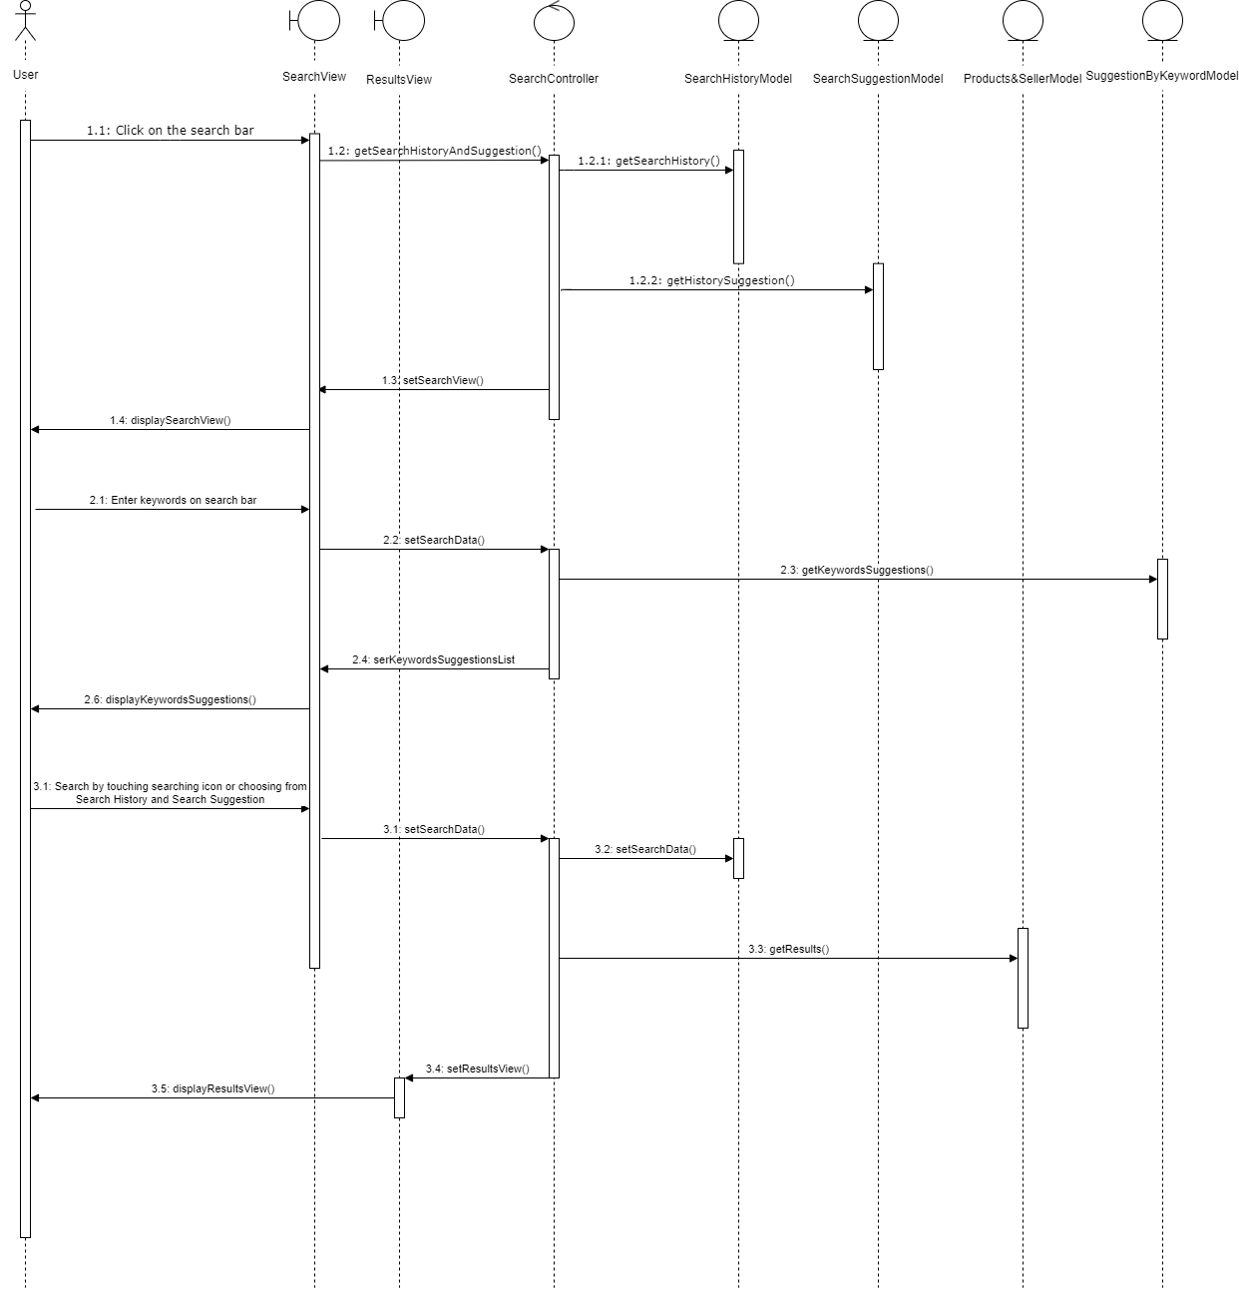

## Class diagram

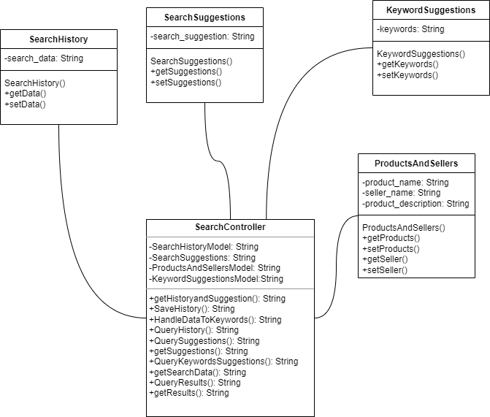

# Derived Requirements

The system should respond promptly to user actions, ensuring a smooth and responsive shopping experience.